IDOR Course A

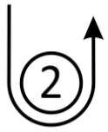
SIGNAL | MARK ROUNDING ORDER
A2 | 1 – 2 – 1 – Finish
A3 | 1 – 2 – 1 – 2 – 1 – Finish
A4 | 1 – 2 – 1 – 2 – 1 – 2 – 1 – Finish

IDOR Course B
SIGNAL | MARK ROUNDING ORDER
B2 | 1 – 1A – 2 – 1 – 1A – Finish
B3 | 1 – 1A – 2 – 1 – 1A – 2 – 1 – 1A – Finish
B4 | 1 – 1A – 2 – 1 – 1A – 2 – 1 – 1A – 2 – 1 – 1A – Finish

IDOR Course C
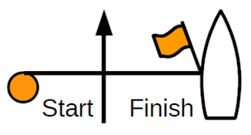
SIGNAL | MARK ROUNDING ORDER
C2 | 1 – 2 – Line – 1 – 2 – Finish
C3 | 1 – 2 – Line – 1 – 2 – Line – 1 – 2 – Finish
C4 | 1 – 2 – Line – 1 – 2 – Line – 1 – 2 – Line – 1 – 2 – Finish

IDOR Course D

SIGNAL | MARK ROUNDING ORDER
D2 | 1 – 1A – 2 – Line – 1 – 1A – 2 – Finish
D3 | 1 – 1A – 2 – Line – 1 – 1A – 2 – Line – 1 – 1A – 2 – Finish
D4 | 1 – 1A – 2 – Line – 1 – 1A – 2 – Line – 1 – 1A – 2 – Line – 1 – 1A – 2 – Finish

IDOR Course E
SIGNAL | MARK ROUNDING ORDER
E3 | 1 – 3 – Line – 1 – 2 – 3 – Line – 1 – 3 – Finish

IDOR Course F
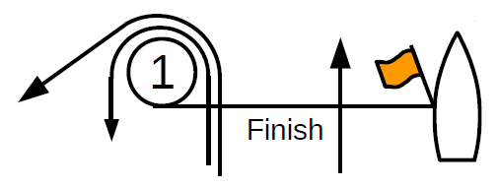

SIGNAL | MARK ROUNDING ORDER
F3 | 1 – 3 – 1 – 2 – 3 – 1 – 3 – Finish

